QUESTION : 1
Create two tables in your database: 'restaurants' (id, name, city) and 'dishes' (id, restaurant_id, dish_name, price). Insert at least 3 restaurants and 2-3 dishes for each restaurant.
TABLES:
- CREATE TABLE restaurants(
id INT,
name VARCHAR(100),
city VARCHAR(100),
PRIMARY KEY(id)
);
- CREATE TABLE dishes(
id INT,
restaurant_id INT,
dish_name VARCHAR(100),
price DECIMAL(5,2),
PRIMARY KEY(id)
);
TABLE VALUES:
- INSERT INTO restaurants(id, name, city)
VALUES(1,'Spice hub','Ahmedabad'),(2,'Pizza world','Surat'),(3,'Food palace','Rajkot');
- INSERT INTO dishes(id,restaurant_id,dish_name, price)
VALUES (1, 1,'Paneer tikka',250), (2, 1,'Veg biryani',220), (3, 2,'Margherita pizza',300), (4, 2,'Garlic bread',150), (5, 3,'Pav bhaji',180), (6, 3,'Masala dosa',200),
(7, 10,'Mystery dish',100);
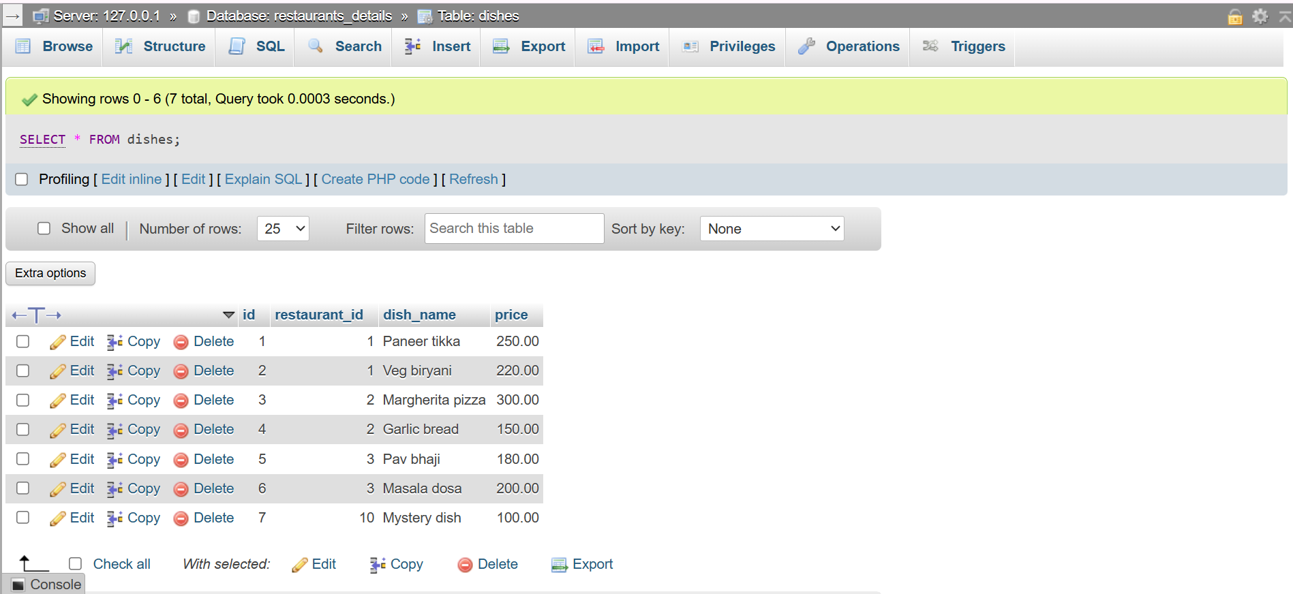
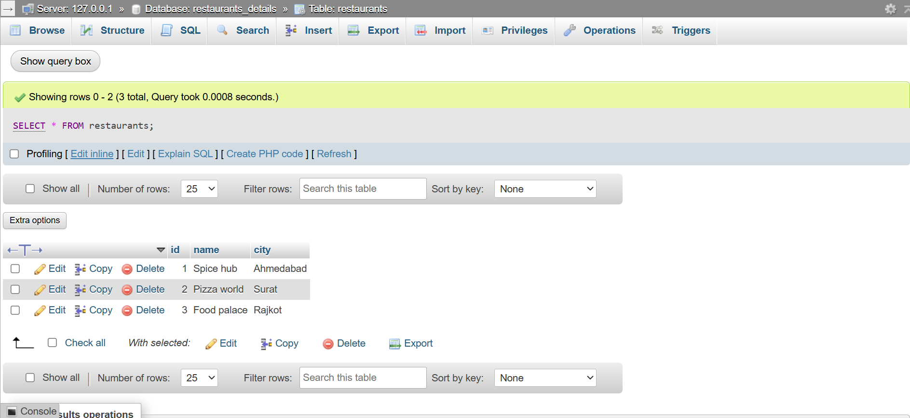

QUESTION : 2
Write an SQL INNER JOIN query to display each dish along with its restaurant name and city, similar to how Zomato shows dish details with the restaurant info.
- SELECT dishes.dish_name,dishes.price,restaurants.name,restaurants.city
FROM dishes INNER JOIN restaurants ON dishes.restaurant_id = restaurants.id;
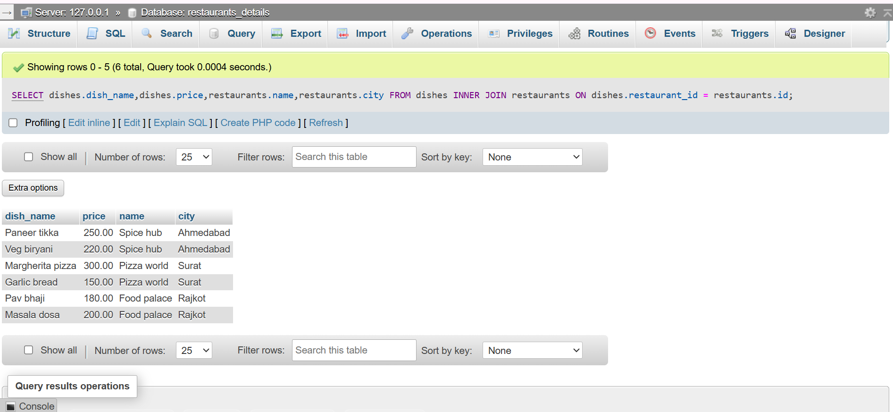

QUESTION : 3
Write an SQL LEFT JOIN query to list all restaurants and their dishes, showing restaurants even if they currently have no dishes on the menu.<br><br><em><strong>Hint:</strong> Use LEFT JOIN so restaurants without dishes still appear in the results with NULL for dish columns.</em>

- SELECT restaurants.name,restaurants.city,dishes.dish_name,dishes.price
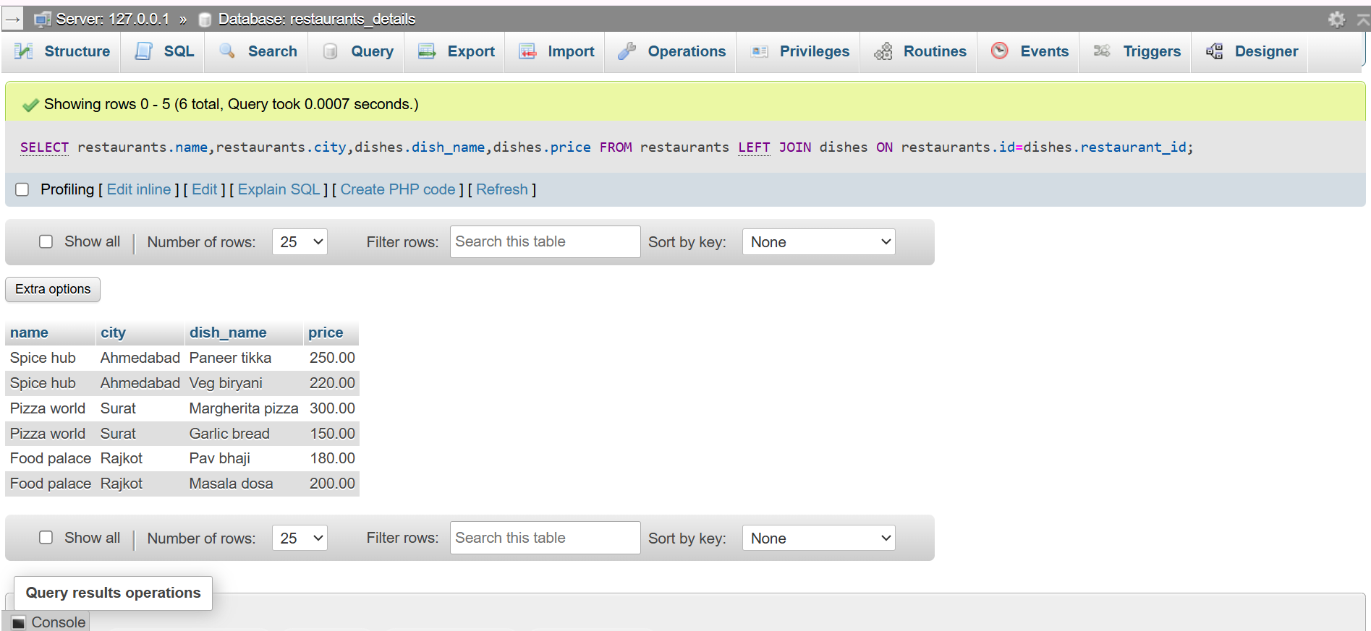
FROM restaurants LEFT JOIN dishes ON restaurants.id=dishes.restaurant_id;

QUESTION : 4
Write an SQL RIGHT JOIN query to display all dishes and their restaurant names, including any dishes that might not be linked to a restaurant (simulate a data error where a dish has a restaurant_id that doesn't match any restaurant).

- SELECT dishes.dish_name,dishes.price,restaurants.name AS restaurants_name
FROM restaurants RIGHT JOIN dishes ON restaurants.id = dishes.restaurant_id;

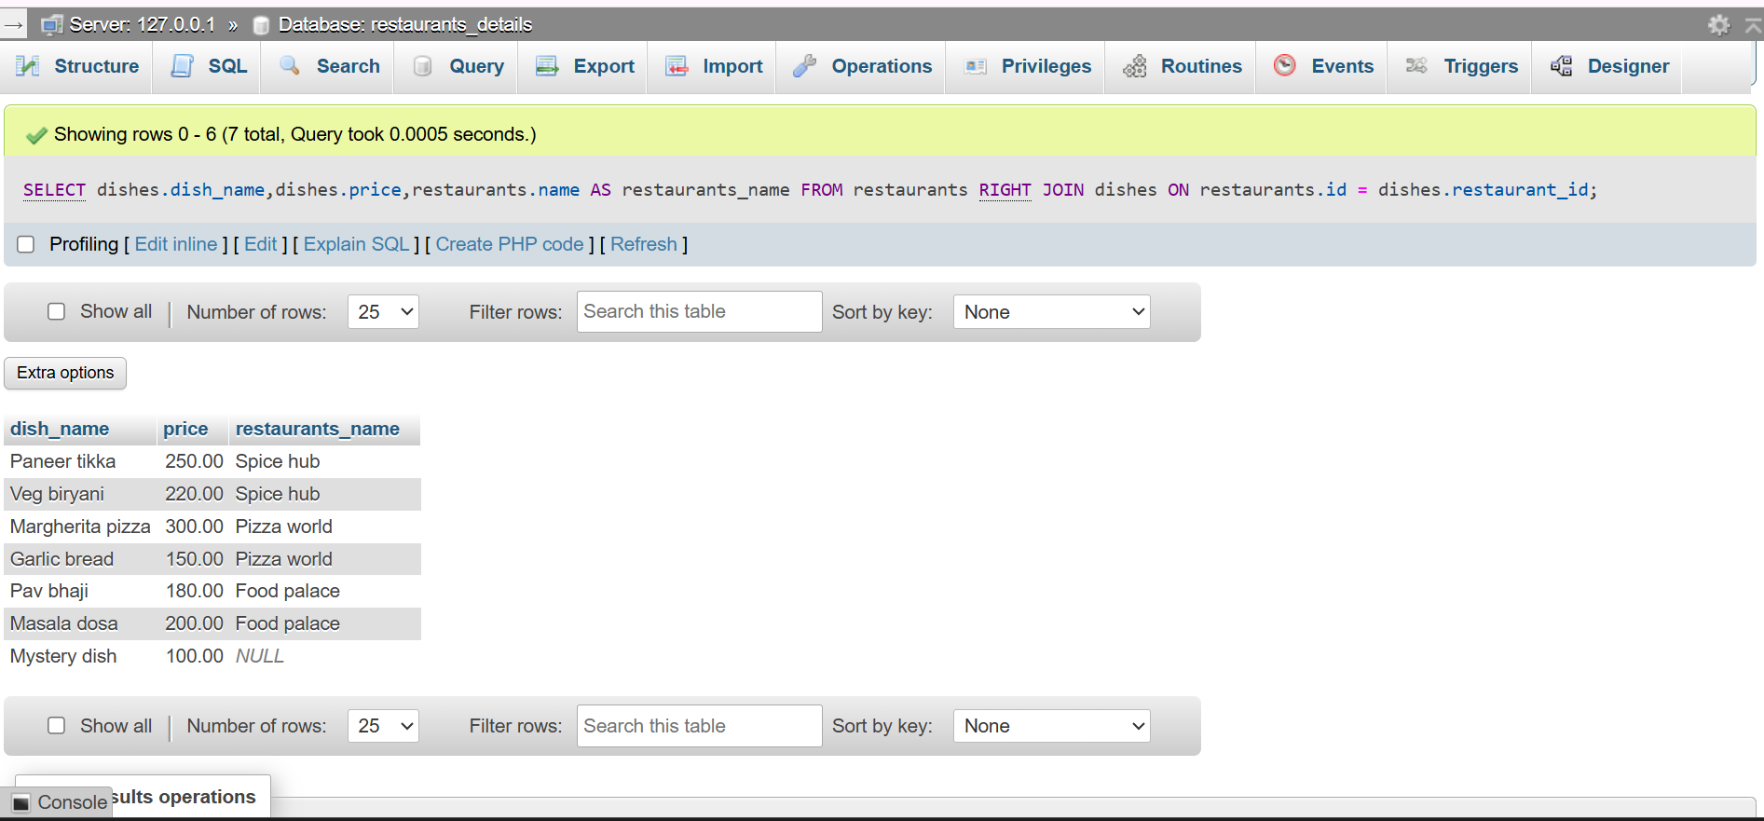
QUESTION : 5
Given this scenario: You want to show a list of all playlists and the songs inside them, like Spotify. Explain which JOIN type (INNER, LEFT, or RIGHT) you would use to show all playlists, even if some are empty, and write the SQL query for it.

JOIN TYPE : LEFT JOIN (because show all playlists)
Tables:
- CREATE TABLE playlists(id INT,playlist_name VARCHAR(100),PRIMARY KEY(id));

- CREATE TABLE songs(id INT,playlist_id INT,song_name VARCHAR(100),PRIMARY KEY(id));

VALUES:
- INSERT INTO playlists(id, playlist_name)
VALUES(1,'Chill hits'),(2,'Workout mix'),(3,'Romantic'),(4,'Party songs');
- INSERT INTO songs(id, playlist_id, song_name)
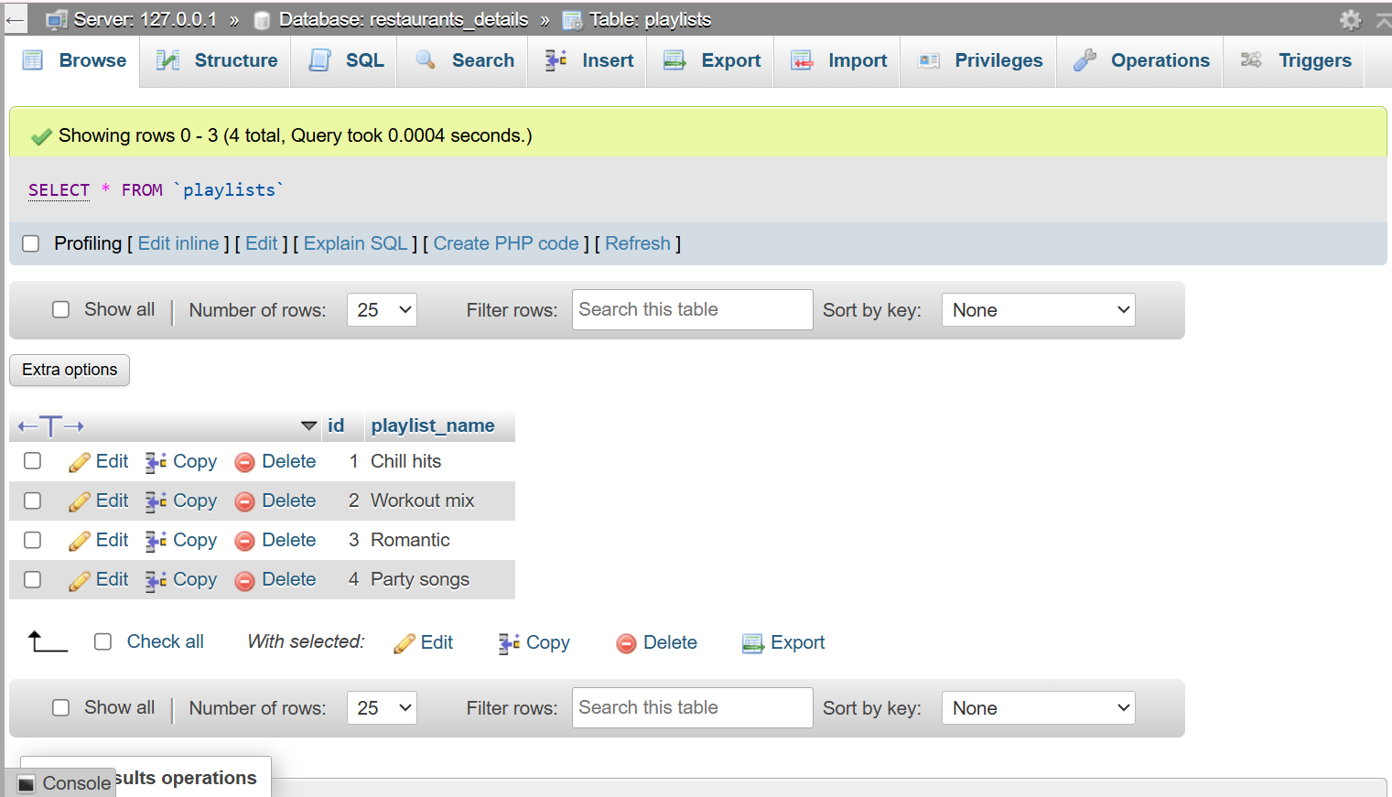
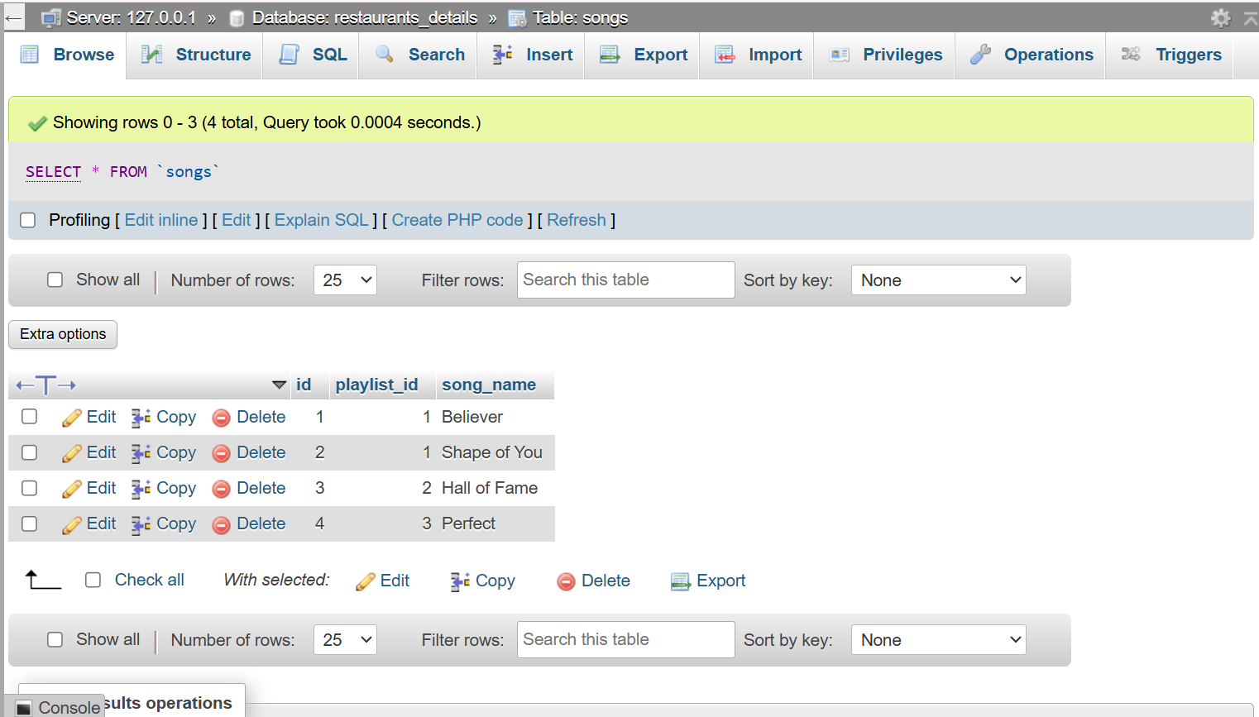
VALUES(1,1,'Believer'),(2,1,'Shape of You'),(3,2,'Hall of Fame'),(4,3,'Perfect');

- SELECT playlists.playlist_name,songs.song_name FROM playlists LEFT JOIN songs
ON playlists.id=songs.playlist_id;
